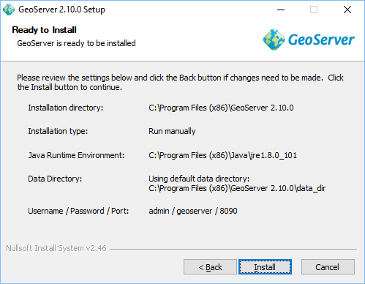

http://docs.geoserver.org/latest/en/user/webadmin/index.html

PostGres 9.6.1
postgres / postgres / 5432

PostGIS 2.3

Inspire extension
http://docs.geoserver.org/stable/en/user/extensions/inspire/using.html#inspire-using

